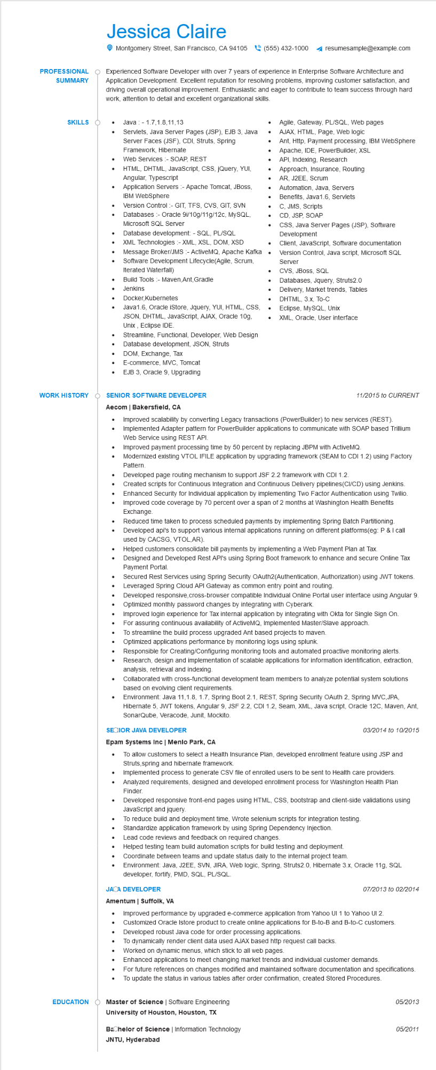
PROFESSIONAL
SUMMARY
SKILLS
Jessica Claire
Montgomery Street, San Francisco, CA 94105(555) 432-1000
resumesample@example.com
Experienced Software Developer with over 7 years of experience in Enterprise Software Architecture and Application Development. Excellent reputation for resolving problems, improving customer satisfaction, and driving overall operational improvement. Enthusiastic and eager to contribute to team success through hard work, attention to detail and excellent organizational skills.
•
•
•
•
Java 1.7,1.8,11,13
Servlets, Java Server Pages (JSP), EJB 3, Java Server Faces (JSF), CDI, Struts, Spring Framework, Hibernate
Web Services :- SOAP, REST
HTML, DHTML, JavaScript, CSS, jQuery, YUI, Angular, Typescript
Application Servers :- Apache Tomcat, JBoss, IBM WebSphere
Version Control:- GIT, TFS, CVS, GIT, SVN Databases - Oracle 9i/10g/11g/12c, MySQL, Microsoft SQL Server
Database development: - SQL, PL/SQL XML Technologies:- XML, XSL, DOM, XSD Message Broker/JMS - ActiveMQ, Apache Kafka
Software Development Lifecycle(Agile, Scrum, Iterated Waterfall)
Build Tools - Maven, Ant, Gradle Jenkins
Docker,Kubernetes
• Java1.6, Oracle iStore, Jquery, YUI, HTML, CSS, JSON, DHTML, JavaScript, AJAX, Oracle 10g, Unix, Eclipse IDE
Streamline, Functional, Developer, Web Design
Database development, JSON, Struts
Agile, Gateway, PL/SQL, Web pages
AJAX, HTML, Page, Web logic
• Ant, Http, Payment processing, IBM WebSphere Apache, IDE, PowerBuilder, XSL
•
•
•
API, Indexing, Research
Approach, Insurance, Routing
AR, J2EE, Scrum
Automation, Java, Servers
Benefits, Java1.6, Servlets
C, JMS, Scripts
CD, JSP, SOAP
CSS, Java Server Pages (JSP), Software Development
Client, JavaScript, Software documentation Version Control, Java script, Microsoft SQL Server
CVS, JBoss, SQL
Databases, Jquery, Struts2.0 Delivery, Market trends, Tables DHTML, 3.x, To-C
Eclipse, MySQL, Unix
• XML, Oracle, User interface
•
DOM, Exchange, Tax
•
E-commerce, MVC, Tomcat
•
EJB 3, Oracle 9, Upgrading
WORK HISTORY
SENIOR SOFTWARE DEVELOPER Aecom | Bakersfield, CA
11/2015 to CURRENT
•
•
....
•
•
Improved scalability by converting Legacy transactions (PowerBuilder) to new services (REST). Implemented Adapter pattern for PowerBuilder applications to communicate with SOAP based Trillium Web Service using REST API.
Improved payment processing time by 50 percent by replacing JBPM with ActiveMQ.
Modernized existing VTOL IFILE application by upgrading framework (SEAM to CDI 1.2) using Factory Pattern.
Developed page routing mechanism to support JSF 2.2 framework with CDI 1.2.
Created scripts for Continuous Integration and Continuous Delivery pipelines (CI/CD) using Jenkins. Enhanced Security for Individual application by implementing Two Factor Authentication using Twilio. Improved code coverage by 70 percent over a span of 2 months at Washington Health Benefits Exchange
Reduced time taken to process scheduled payments by implementing Spring Batch Partitioning. Developed api's to support various internal applications running on different platforms (eg: P & I call used by CACSG, VTOL,AR).
• Helped customers consolidate bill payments by implementing a Web Payment Plan at Tax. Designed and Developed Rest API's using Spring Boot framework to enhance and secure Online Tax Payment Portal.
•
Secured Rest Services using Spring Security OAuth2 (Authentication, Authorization) using JWT tokens. Leveraged Spring Cloud API Gateway as common entry point and routing.
Developed responsive, cross-browser compatible Individual Online Portal user interface using Angular 9. Optimized monthly password changes by integrating with Cyberark.
Improved login experience for Tax internal application by integrating with Okta for Single Sign On.
•
For assuring continuous availability of ActiveMQ, Implemented Master/Slave approach.
•
To streamline the build process upgraded Ant based projects to maven.
Optimized applications performance by monitoring logs using splunk.
Responsible for Creating/Configuring monitoring tools and automated proactive monitoring alerts.
Research, design and implementation of scalable applications for information identification, extraction, analysis, retrieval and indexing.
Collaborated with cross-functional development team members to analyze potential system solutions based on evolving client requirements.
Environment: Java 11,1.8, 1.7, Spring Boot 2.1, REST, Spring Security OAuth 2, Spring MVC,JPA, Hibernate 5, JWT tokens, Angular 9, JSF 2.2, CDI 1.2, Seam, XML, Java script, Oracle 12C, Maven, Ant, SonarQube, Veracode, Junit, Mockito.
SECIOR JAVA DEVELOPER
Epam Systems Inc | Menlo Park, CA
•
•
•
03/2014 to 10/2015
To allow customers to select a Health Insurance Plan, developed enrollment feature using JSP and Struts,spring and hibernate framework.
Implemented process to generate CSV file of enrolled users to be sent to Health care providers. Analyzed requirements, designed and developed enrollment process for Washington Health Plan Finder.
Developed responsive front-end pages using HTML, CSS, bootstrap and client-side validations using JavaScript and jquery.
To reduce build and deployment time, Wrote selenium scripts for integration testing.
Standardize application framework by using Spring Dependency Injection.
Lead code reviews and feedback on required changes.
Helped testing team build automation scripts for build testing and deployment. Coordinate between teams and update status daily to the internal project team.
Environment: Java, J2EE, SVN, JIRA, Web logic, Spring, Struts2.0, Hibernate 3.x, Oracle 11g, SQL developer, fortify, PMD, SQL, PL/SQL.
JACA DEVELOPER
Amentum | Suffolk, VA
07/2013 to 02/2014
•
Improved performance by upgraded e-commerce application from Yahoo UI 1 to Yahoo UI 2. Customized Oracle Istore product to create online applications for B-to-B and B-to-C customers. Developed robust Java code for order processing applications.
To dynamically render client data used AJAX based http request call backs.
Worked on dynamic menus, which stick to all web pages.
Enhanced applications to meet changing market trends and individual customer demands.
For future references on changes modified and maintained software documentation and specifications. To update the status in various tables after order confirmation, created Stored Procedures.
EDUCATION
Master of Science | Software Engineering
University of Houston, Houston, TX
Bachelor of Science | Information Technology
JNTU, Hyderabad
05/2013
05/2011

